Case Study 10: Food Waste Monitoring

1. Problem Statement
Calculate leftover meals and the percentage of food wasted in a canteen.

2. Objectives
- Calculate leftover meals.
- Calculate waste percentage.

3. Assumptions
- Meals prepared must be greater than zero for percentage calculation.
- Meals served cannot exceed meals prepared.

4. Algorithm
1. Read meals prepared and served.
2. Validate values.
3. Leftovers = prepared − served.
4. Calculate percentage wasted.
5. Display results.

5. Flowchart
START → Input meals prepared and served → Validate → Calculate leftovers → Calculate waste percentage → Display → STOP
For a drawn flowchart, use: oval for START/STOP, parallelogram for input/output, rectangle for calculations, and diamond for decisions.

6. Pseudocode
READ prepared, served
IF prepared <= 0 OR served < 0 OR served > prepared: DISPLAY invalid
ELSE waste = prepared - served
percentage = waste / prepared * 100
DISPLAY waste, percentage

7. Python Source Code
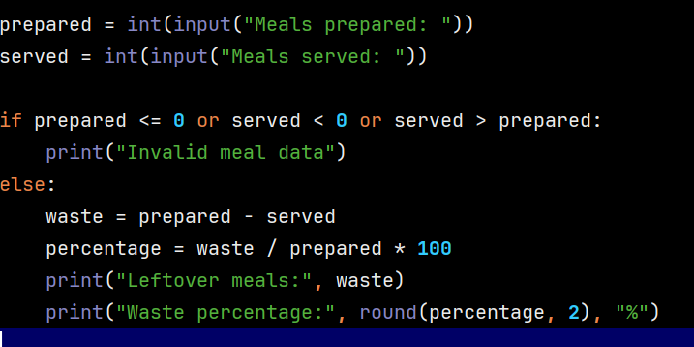

8. Test Cases
Test 1: 100 prepared, 85 served → 15 leftovers, 15%. Test 2: 80 prepared, 76 served → 4 leftovers, 5%.

Sample Output
Input: meals prepared 100, meals served 85
Output: Leftover meals: 15
Waste percentage: 15.0 %

9. Conclusion
The program helps monitor leftover food and calculate the percent

